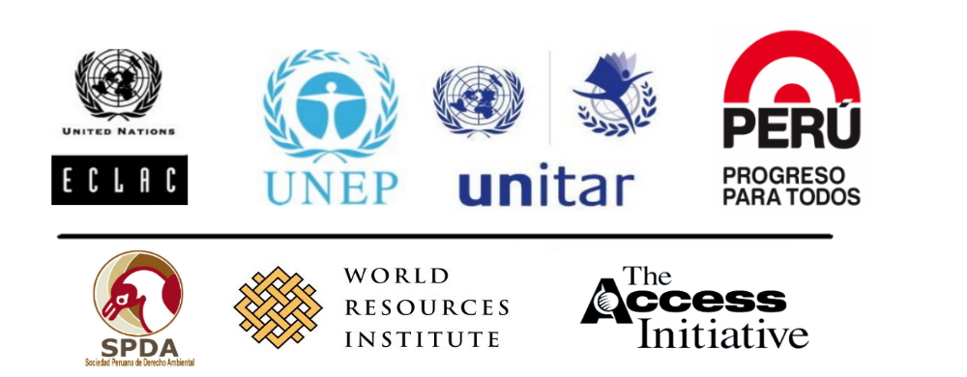

Regional Workshop on the Implementation of Rio Principle 10 and Application of the Guidelines for the Development of National Legislation on Access to Information, Public Participation and Access to Justice in Environmental Matters
in Latin America
Ministry of Foreign Affairs, Lima, Peru
October 28-29, 2013
Preliminary Programme

This workshop is part of the Eye on Earth Special Initiative “Access for All”


Background

Strengthening effective engagement of all stakeholders in environmental decision-making is considered an important pre-requisite of sustainable development. Principle 10 of the Rio Declaration (“Rio Principle 10”) was adopted at the 1992 Rio Summit by Heads of State and Government with the goal to strengthen access to information, public participation and access to justice in environmental matters.

In February 2010 a milestone was achieved in the field of environmental law and application of Principle 10 when the Special Session of the UNEP Governing Council, Global Ministerial Environment Forum (GMEF) in Bali, Indonesia, unanimously adopted the ‘Guidelines for the Development of National Legislation on Access to Information, Public Participation in Decision-making and Access to Justice in Environmental Matters’ (Bali Guidelines). These Guidelines seek to assist countries in filling possible gaps in their respective relevant national legislation, and -where relevant and appropriate- in sub-national legal norms and regulations at the State or district levels etc., to facilitate broad access to information, public participation and access to justice in environmental matters. Responding to country requests for capacity development for Principle 10 implementation and implementation of the Bali Guidelines, UNEP and UNITAR have launched a 2-year joint global capacity development initiative, including a regional workshop component. The project is part of the “Access for All” Special Initiative an initiative endorsed at the 2011 Eye on Earth Summit in Abu Dhabi.

In the preparations and during the 2012 UN Conference on Sustainable Development (Rio+20) Governments and stakeholder groups have pointed to the need for global, regional and national steps to enhance implementation of Principle 10. As a result, The Declaration on the implementation of Principle 10 of the Rio Declaration on Environment and Development in Latin America and the Caribbean was signed in the framework of the Rio +20 Conference. In the Declaration, the signatory countries: Argentina, Brazil, Chile, Colombia, Costa Rica, Ecuador, Honduras, Jamaica, Mexico, Panama, Paraguay, Peru, Dominican Republic, Trinidad and Tobago, and Uruguay, committed to develop a Plan of Action to 2014, with the support of the Economic Commission for Latin America and the Caribbean (ECLAC) as Technical Secretariat, to advance the achievement of a regional instrument on the rights of access to information, participation and environmental justice, which enshrines Rio Principle 10

In view of the above mentioned developments, UNEP, UNITAR, ECLAC and others have joined forces to cooperatively support the development of Principle 10 and the application of the Bali Guidelines in Latin America and the Caribbean. This workshop presents a joint effort to raise awareness among countries in the region on Principle 10, the Declaration on the application of Principle 10 in LAC and the Bali Guidelines and will be followed by targeted activities to assist interested and committed countries to implement the Bali Guidelines at the national level.

The workshop will be an opportunity for representatives from countries from Latin Amercia to review progress with regard with public participation, access to information and access to justice in Latin America.

The workshop will target all relevant governmental and non-governmental stakeholders.

Workshop Objectives

- Take stock and identify key issues for effective implementation of Principle 10 in the region
- Introduce and discuss relevance of the Guidelines for Development of National Legislation on Access to Information, Public Participation and Access to Justice in Environmental Matters (Bali Guidelines) and the Declaration on the implementation of Principle 10 of the Rio Declaration on Environment and Development in Latin America and the Caribbean.
- Exchange good practices and lessons learned for the three pillars of Principle 10 (public participation, access to information, access to Justice)
- Identify opportunities for action, capacity development and networking
- Identify countries needs for the implementation of the Bali Guidelines

By the end of the workshop, participants will be able to:

- Cite good practices of Principle 10 implementation in the region.
- Analyze key provisions of the Bali Guidelines and their relevance for national legislation.
- Initiate steps and support action for national follow-up.
- Participate effectively in international and regional processes related to Principle 10 implementation.
- Know about capacity development needs at the country level for the effective implementation of Bali Guidelines. This information will be a key input for the Working Group on Capacity Bulding and Cooperation, established under the Plan of Action to 2014 of of the Principle 10 Declaration in Latin America and the Caribbean.

Preliminary Program

Day 1:
8.30h – 9.00h: Registration

9.00h – 9.20h: Welcome Remarks and Inauguration of the Workshop (with interpretation)

- Representative(s) of the Government of Peru (5 minutes)
- Fatou Ndoye, Major Groups and Stakeholders Branch, Division of Regional Cooperation, United Nations Environment Programme (UNEP) (on behalf of UNEP and UNITAR, 5 minutes)
- RepresentativeEconomic Commission for Latin America and the Caribbean (ECLAC, 5 minutes)
- Carole Excell, Senior Associate, The Access Initiative, World Resources Institute (WRI, 5 minutes)and/or Isabel Calle, Sociedad Peruana de Derecho Ambiental.

9.20h – 9.40h: Workshop Objectives and Methodology and Introduction of Participants (with interpretation)

- Achim Halpaap, Associate Director, Training Department, Head Environment Unit, UNITAR (20 minutes)

9.40h – 10.40h: Implementation of Principle 10 and the Bali Guidelines in Latin America: International Context (with interpretation)

- Stephen Stect (UNEP): ‘Guidelines for the Development of National Legislation on Access to Information, Public Participation in Decision-making and Access to Justice in Environmental Matters’ (Bali Guidelines).
- Constance Nalegach (Focal Point Chile, Presidency of the Presiding Officers of the Declaration on the application of Principle 10 of the Rio Declaration on Environment and Development in Latin America and the Caribbean)

- Questions and Answers

10.40h – 11.00h: Coffee break

Session 1 : Identifying Good Practices and Lessons in the Region

Objective: For the key pillars of Principle 10 - information, participation, justice - provide case illustration, identify good practices and implementation challenges in countries in the region and introduce legal guidance contained in the Bali Guidelines

11.00h – 13.00: Theme 1: Access to Information (no interpretation)

- Brief introduction to relevant provisions of the Bali Guidelines and the Bali Guideline Implementation Handbook (Andrea Brusco, 20 minutes)
- Access to information on environmental matters in Latin America (Tomás Severino, Cultura Ecologica, Mexico, 10 minutes)
- Working groups ( 1/12 hours). The facilitated Working Groups will discuss (working group facilitators: Carolina Neme from GAIA Uruguay and Paula Martins from Article 19 Brazil):
  - How can the provisions of the Bali Guildelines related to Access to Information be used to improve national framework or sector relevant legislations (e.g. forestry, fishery, mining) in your country?
  - What are the types of follow up activities that would be needed in your country to promote the use of these guidelines by government and by civil society? Is there room for cross country learning in the implementation of these guidelines?

13.00h – 14.00h: Lunch Break

14.00h – 16.00h Theme 2: Public Participation (no interpretation)

• Brief introduction to relevant provisions of the Bali Guidelines (Andrea Brusco, 20 minutes)
• Public participation in environmental matters in Latin America (Daniel Ryan, FARN, Argentina or Andrea Sanhueza TAI, TBC, 10 minutes)
- • Working groups (1h, 30 minutes). The facilitated Working Groups will discuss (working group facilitators: Ceciliar Olivares from UNES, El Salvador, and Patricia Madrigal, from Coopesolidar Costa Rica):
  - How can the provisions of the Bali Guildelines related to Public Participation be used to improve national framework or sector relevant legislations (e.g. forestry, fishery, mining) in your country?
  - What are the types of follow up activities that would be needed in your country to promote the use of these guidelines by government and by civil society? Is there room for cross country learning in the implementation of these guidelines?

16.00h – 18.00h: Theme 3: Access to Justice (no interpretation)

- Brief introduction to relevant provisions of the Bali Guidelines and the Rio + 20 Declaration on Justice, Governance and Law for Environmental Sustainability (Andrea Brusco, UNEP, 20 minutes)
- Access to justice in environmental matters in Latin America (Judge Antonio Benjamín, Brazil TBC))
- Working groups ( 1 hours, 30 minutes). The facilitated Working Groups will discuss (working group facilitators: Daniel Ryan FARN, Argentina and Luisa Arauz from Panamá):
  - How can the provisions of the Bali Guildelines related to Access to Justice be used to improve national framework or sector relevant legislations (e.g. forestry, fishery, mining) in your country?
  - What are the types of follow up activities that would be needed in your country to promote the use of these guidelines by government and by civil society? Is there room for cross country learning in the implementation of these guidelines?

Day 2

Session 1 (cont.)

8.30h – 10.00h Reporting in Plenary (with interpretation)

- 30 minutes per working group, all three themes

Session 2: Advancing National Action and Capacity Development

Objective: Explore opportunities for national action and capacity development to effectively implement Principle 10 at the national level, addressing also regional synergies

10.00h – 11.00: National Implementation of the Bali Guildelines: Opportunities for Capacity Development Support (with interpretation)

- Achim Halpaap/UNITAR and Fatou Ndoye/UNEP

- Questions and Answers

Session: 3: Conclusion and Follow-up Action

11.00h – 11.30h: Review key outcomes of the workshop discussion and identify recommendations for follow-up/Workshop Closure (with interpretation)

- Open discussion in plenary
- Workshop evaluation
- Workshop closure

